 | VICTORIA JUNIOR COLLEGE  JC 2 PRELIMINARY EXAMINATIONS  Higher 2
CHEMISTRY |  |  | 9647/01
Paper 1 Multiple Choice |  |  |  | 24 September 2010  1 hour
Additional Materials: |  | Multiple Choice Answer Sheet  Data Booklet

READ THESE INSTRUCTIONS FIRST

Write in soft pencil.
Do not use staples, paper clips, highlighters, glue or correction fluid.
Write your NRIC/FIN number, name and CT group on the Answer Sheet.

There are forty questions. Answer all questions. For each question there are four possible answers A, B, C and D.
Choose the one you consider correct and record your choices in soft pencil on the separate Answer Sheet.

Read the instructions on the Answer Sheet very carefully.

Each correct answer will score one mark. A mark will not be deducted for a wrong answer.
Any rough working should be done in this booklet.

This document consists of 18 printed pages.
Section A

For each question there are four possible answers, A, B, C, and D. Choose the one you consider to be correct.

1 Arsenic, As (A_{r} = 74.9), is a poison commonly used in pesticides. To determine the mass of arsenic present in a sample of pesticide, all the arsenic was first converted to arsenate ion, AsO₄³⁻. 1.25 × 10⁻³ mol of AgNO₃ was then added to precipitate AsO₄³⁻ as Ag₃AsO₄. The excess Ag⁺ ions needed 18.2 cm³ of 0.0108 mol dm⁻³ KSCN to form silver thiocyanate, AgSCN.

What is the mass of arsenic present in the sample of pesticide?

A 0.015 g C 0.031 g
B 0.026 g D 0.079 g

2 Consider the table below.

Particle | Number of neutrons | Number of nucleons
Q⁻ | 16 | 33
R⁺ | 19 | 39
S²⁻ | 17 | 33
T²⁺ | 18 | 35

Which of the following pairs consists of particles that are isoelectronic?

A Q⁻ and S²⁻
B R⁺ and S²⁻
C S²⁻ and T²⁺
D Q⁻ and T²⁺

3 In which pair below does the first species have a bigger bond angle than the second species?

A CO₃²⁻and SO₃²⁻ C NH₃ and SiH₄
B ICl₄⁻ and SCl₂ D CF₄ and BrF₂⁻

4 Which statement about the properties of graphite is incorrect?

A It can be used as a lubricant because of the weak forces of attraction between layers of atoms.

B It is a good conductor of electricity in the direction parallel to each layer.

C The carbon to carbon distance between different layers is the same as that within each plane.

D Each carbon atom is sp² hybridised.

5 Use of the Data Booklet is relevant to this question.

The enthalpy change of formation of methane is given below.

C(graphite) + 2H₂(g) → CH₄(g) ΔHº = −75 kJ mol⁻¹

What is the standard enthalpy change of atomisation of graphite?

A +350 kJ mol⁻¹ C +843 kJ mol⁻¹
B +693 kJ mol⁻¹ D +1130 kJ mol⁻¹

6 The table below contains the reduction potential values for various copper and mercury species.

half-equations | Eº/ V
Cu²⁺ (aq) + e ⇌ Cu⁺ (aq) | +0.15
Cu⁺(aq) + e ⇌ Cu (s) | +0.52
Hg²⁺(aq) + e ⇌ Hg⁺(aq) | +0.91
Hg⁺(aq) + e ⇌ Hg(l) | +0.80

Using these data, which one of the following is a correct prediction?

A Both Cu⁺ and Hg⁺ undergo disproportionation.
B Only Cu⁺ undergoes disproportionation.
C Only Hg⁺ undergoes disproportionation.
D Neither Cu⁺ nor Hg⁺ undergoes disproportionation.

7 A cell is constructed with zinc and carbon electrodes, each weighing 50 g, partly immersed in aqueous KOH.
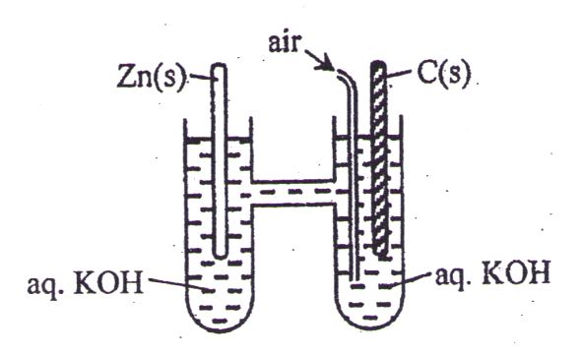

When connected in a circuit, some zinc passes into the solution as zincate(II) ions, ZnO₂²⁻(aq). The cell delivers a current of 1.68  10⁻² A. The zinc electrode is replaced once 60% of it is used up.

What is the time taken, in seconds, before replacement of zinc electrode becomes necessary?

A 2.63  10⁶ C 5.27 x 10⁶
B 4.39  10⁶ D 8.78 x 10⁶

8 The graphs below show the variation of the percentage of gaseous products present at equilibrium, with temperature and pressure.
pressure
% products
at
equilibrium
(T + 10) ºC
T ºC

Which one of the following systems could the graphs represent?

A N₂(g) + 3H₂(g) ⇌ 2NH₃(g) ΔH = –92 kJ mol^{–1}
B 3O₂(g) + 4NH₃(g) ⇌ 2N₂(g) + 6H₂O(g) ΔH = –1248 kJ mol^{–1}
C 2N₂(g) + O₂(g) ⇌ 2N₂O(g) ΔH = +82 kJ mol^{–1}
D CO₂(g) + C(s) ⇌ 2CO(g) ΔH = +173 kJ mol^{–1}

9 An equilibrium can be represented by the equation below.

W (aq) + X (aq) ⇌ Y (aq) + Z (aq)

In 1 dm³ of a certain mixture, the concentrations of these substances at equilibrium were as shown:

substance | concentration / mol dm⁻³
W | 0.5
X | 4.0
Y | 6.0
Z | 8.0

A certain amount of Z was added to the mixture. How many moles of Z would have to be added so that the new equilibrium [W] is 1.0 mol dm⁻³?

A 0.5 C 12.1
B 8.0 D 19.6

10 The equilibrium constant for the hydrolysis of the cobalt(II) cation, K_{h}, is defined as

Co(H₂O)₆ ²⁺(aq) + H₂O(l) ⇌ [Co(H₂O)₅(OH)]⁺(aq) + H₃O⁺(aq)

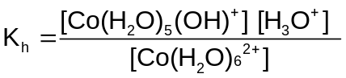

Given that K_{h} = 5.0  10⁻¹⁰ mol dm⁻³, what is the pH of a 0.200 mol dm⁻³ CoBr₂ solution?

A 4.3 C 6.5
B 5.0 D 10.0

11 When the concentration of Ca²⁺ ions in water is greater than 10⁻⁵ mol dm⁻³, an insoluble scum would be formed with soap.

To prevent scum formation, what is the minimum mass of sodium carbonate that should be added to 1 dm³ of water? [K_{sp} of CaCO₃ = 5.0 x 10⁻⁹ mol² dm⁻⁶]

A 6.4  10⁻³ g C 4.2  10⁻² g
B 3.7  10⁻² g D 5.3  10⁻² g

12 Azomethane decomposes when heated according to the following equation.

CH₃N=NCH₃(g) → CH₃CH₃(g) + N₂(g)

This reaction is first order with respect to azomethane with a half life of 20 min.

In one experiment, azomethane was allowed to decompose at 16 Pa and 600 K. The pressure of the reaction mixture was measured at various times with the temperature kept constant. What is the time taken for the pressure to reach 30 Pa?

A 20 min C 40 min
B 37.5 min D 60 min

13 The sketch shows the atomic radii of five elements in order of increasing proton number.

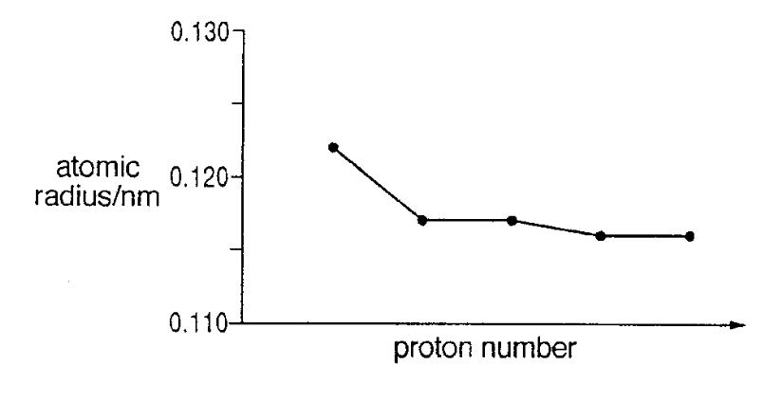
In which part of the Periodic Table do these elements belong?

A Group II C the period sodium to chlorine
B Group VII D the transition metals

14 Which of the following decreases down Group II?

A Reducing power of the elements
B Magnitude of enthalpy change of hydration of the Group II cations
C Thermal stability of the carbonates
D pH of the oxides in water

15 Aqueous chlorine is added to aqueous sodium bromide and the mixture is shaken with an equal volume of trichloroethane.

Which observation would be made?

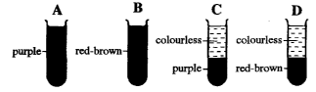

16 Below is a scheme of reaction for a salt T.

white precipitate
BaCl₂(aq) in excess

filter

T

blue filtrate
excess NH₃(aq)

deep blue solution

What is the identity of T?

A chromium(III) chloride C copper(II) chloride
B chromium(III) sulfate D copper(II) sulfate

17 When crystalline potassium chromate(VI) was dissolved in water, a yellow solution Q was formed. Addition of dilute sulfuric acid to Q gave an orange solution R. When hydrogen sulfide was bubbled through solution R, there was a color change in the solution and yellow sulfur was produced.

Which process did not occur in the above experiment?

A ligand exchange C precipitation
B redox reaction D acid-base

18 β-Caryophyllene is an odiferous sesquiterpene used by the cotton plant to attract the male cotton boll weevil.
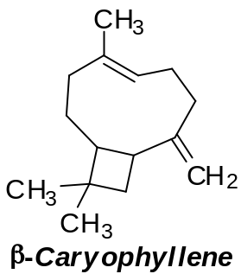
X is the major product formed when β-caryophyllene is reacted with HBr in CCl₄. How many stereoisomers does X have?

A 4 C 16
B 8 D 32

19 An alkyne (C≡C) undergoes hydration in a similar mechanism as an alkene. However, the formation of enol (C=C-OH) is unstable and would undergo rearrangement to form a carbonyl compound.
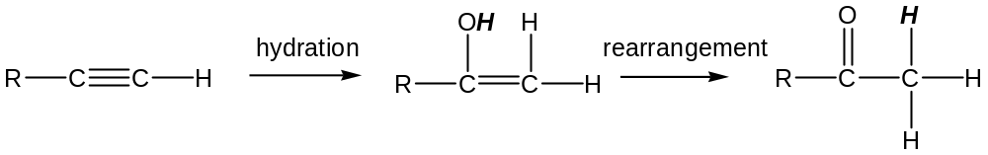Which compound will not be formed when the following alkynes undergo hydration?
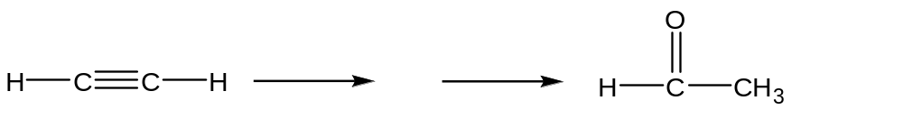

A
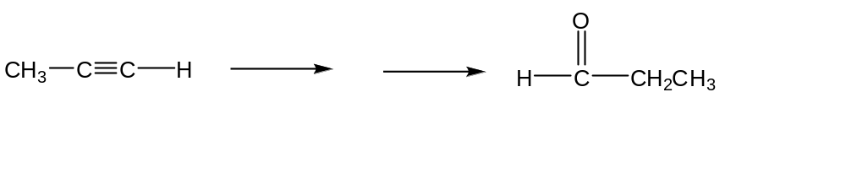

B

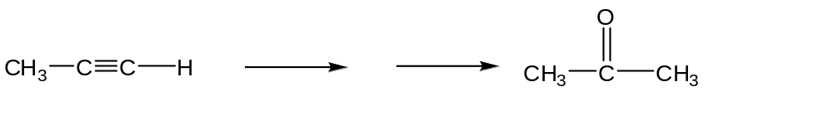

C

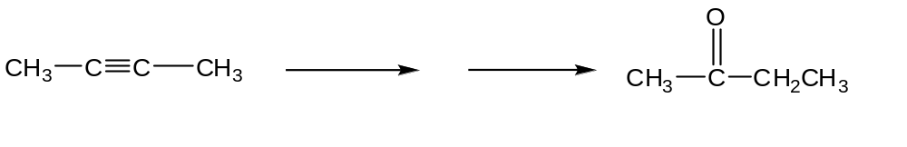

D

20 Which type of reaction does the following compound not undergo?

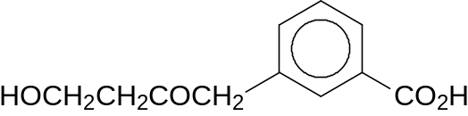

A electrophilic addition C nucleophilic addition
B electrophilic substitution D nucleophilic substitution

21 Which statement best describes the reaction mechanism involved in the single step conversion of chloroethane to ethanol?

A The reaction involves removal of HCl, followed by the addition of H₂O.
B The reaction involves heterolytic fission of the C–Cl bond, followed by a reaction with H₂O.
C The reaction involves nucleophilic attack of OH– in a bimolecular mechanism.
D The reaction mechanism involves a carbocation.

22 Which of the following compounds react with hot acidified KMnO₄ and the resultant product formed will give a positive test with both 2,4-dinitrophenylhydrazine and PCl₅?
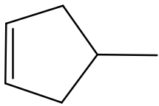

A

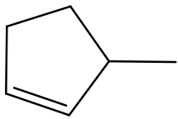

B

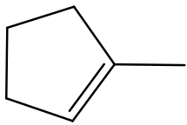

C

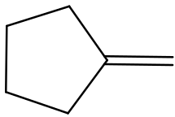

D

23 Which of the following 2-stage processes will not yield the final product as shown?

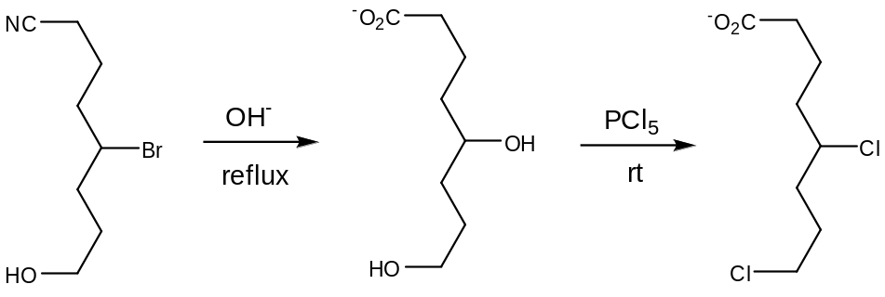

A

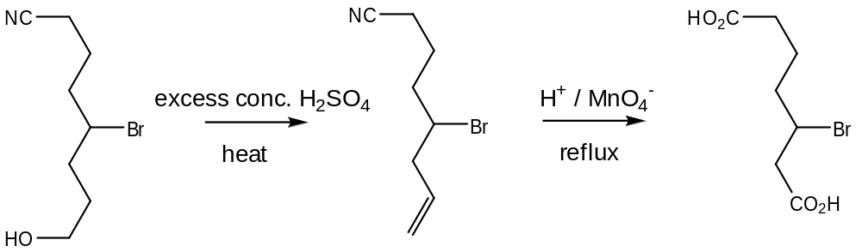

B

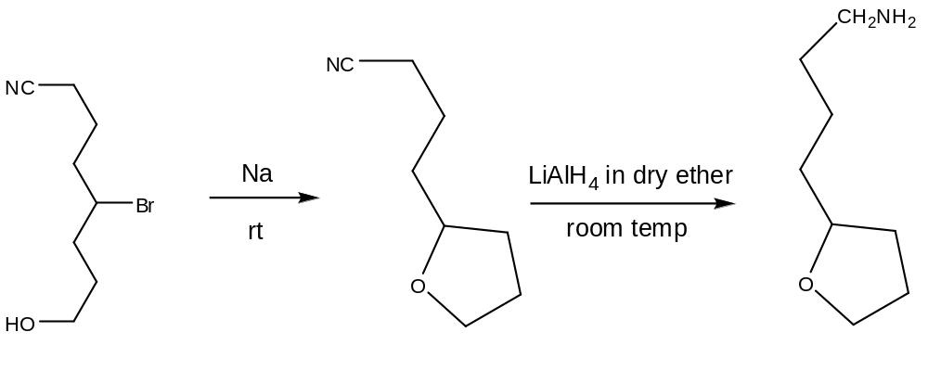

C

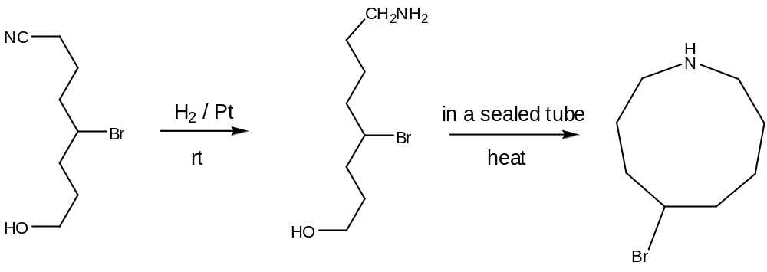

D

24 Consider the compound Y which has the structural formula as shown.

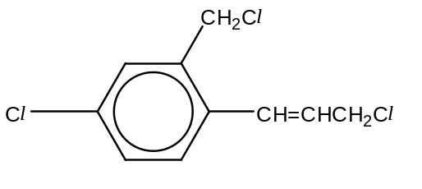
compound Y

1 mole of compound Y is warmed with excess aqueous sodium hydroxide. The resulting solution is cooled and acidified with dilute nitric acid. How many moles of silver chloride will be precipitated out when excess aqueous silver nitrate is then added?

A 0 C 2
B 1 D 3

25 A mixture is made by mixing excess aqueous sodium carbonate with phenylmethanol, phenol and methanoic acid. Which organic species is/are present in the organic layer of the solution?

A phenylmethanol
B methanoic acid
C phenylmethanol and phenol
D phenylmethanol, phenol and methanoic acid

26 Enalapril is used to treat hypertension.

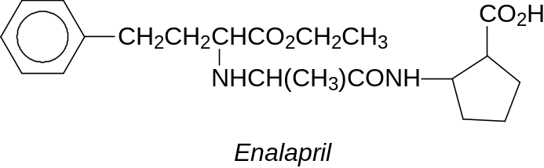

Which of the following statements about Enalapril is true?

A Enalapril decolourises acidified K₂Cr₂O₇.
B Enalapril gives an orange precipitate with 2,4-dinitrophenylhydrazine.
C One mole of Enalapril reacts with 3 moles of CH₃COCl.
D One mole of Enalapril reacts with 3 moles of NaOH.

27 Compound M can be synthesised as shown below.

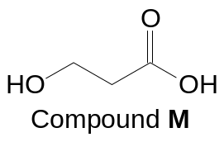

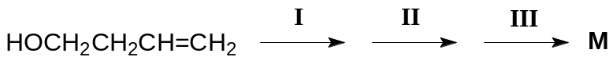

What are the reagents used for steps I, II and III?

 | I | II | III
A | H⁺/KMnO₄(aq) | PCl₅ | NaOH(aq)
B | H⁺/KMnO₄(aq) | PCl₅ | H₂O
C | 1. concentrated H₂SO₄  2. H₂O | NaOH(aq), I₂(aq) | HCl(aq)
D | 1. concentrated H₂SO₄  2. H₂O | OH–/KMnO₄(aq) | HCl(aq)

28 When equimolar amounts of organic compounds R, S, T and U are added separately to water, solutions of increasing pH values are obtained.

Which set of identities of compounds R to U is correct?

 | R | S | T | U
A | CH₃CH₂CO₂H | CH₃CH₂COCl | CH₃CH₂CONH₂ | CH₃CHClCH₂NH₂
B | CH₃CH₂CO₂H | CH₃CH₂COCl | CH₃CHClCH₂NH₂ | CH₃CH₂CONH₂
C | CH₃CH₂COCl | CH₃CH₂CO₂H | CH₃CH₂CONH₂ | CH₃CHClCH₂NH₂
D | CH₃CH₂COCl | CH₃CH₂CO₂H | CH₃CHClCH₂NH₂ | CH₃CH₂CONH₂

29 Which compound decolourise brown bromine in the dark?

A 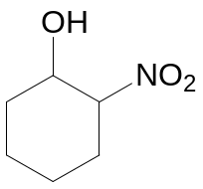 C 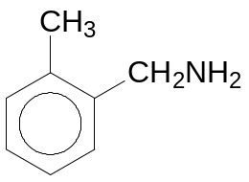

B 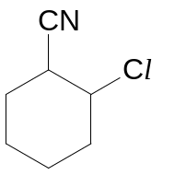 D 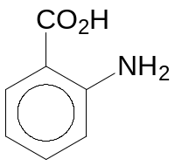

30 Which of the following pairs of protein segments has an interaction which is likely to be broken due to a change in pH?

A 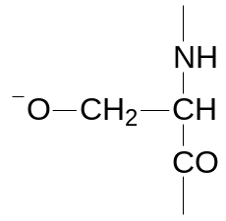 and 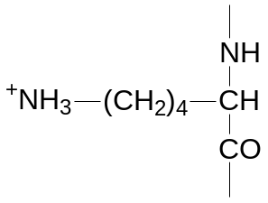
B 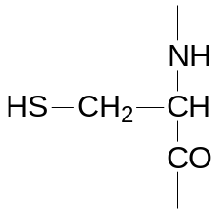 and
C 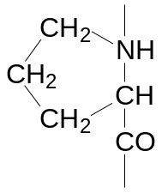 and 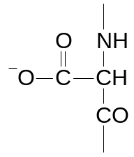
D 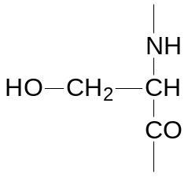 and 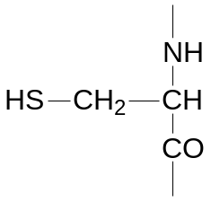

Section B

For each of the questions in this section, one or more of the three numbered statements 1 to 3 may be correct.

Decide whether each of the statements is or is not correct (you may find it helpful to put a tick against the statements that you consider to be correct).

The responses A to D should be selected on the basis of

A | B | C | D
1, 2 and 3  are  correct | 1 and 2  only are  correct | 2 and 3  only are  correct | 1 only  is  correct

No other combination of statements is used as a correct response.

31 Carbon disulphide, CS₂, is a volatile flammable liquid used in the manufacture of cellophane. On combustion, CS₂ is oxidised as follows.

CS₂(g) + 3O₂(g) → CO₂(g) + 2SO₂(g)

Which statements are correct?

1 When 20 cm³ of CS₂ is reacted with 100 cm³ of oxygen, 60% of the final gas volume will dissolve in aqueous alkali.
2 38.1 g of CS₂ will react exactly with 33.6 dm³ of O₂ under standard temperature and pressure.
3 When 30 cm³ of CS₂ is reacted with 60 cm³ of O₂, 30 cm³ of CO₂ will be produced.

32 The conversion of graphite into diamond is a non–spontaneous reaction at 298 K. The entropy change of this reaction is negative at 298 K.

C(graphite) → C(diamond) ΔG = +3.08 kJ mol^{–1} , ΔS = –3.3 J mol^{–1} K^{–1}

With reference to the enthalpy change, ΔH, of the reaction above, which statements are correct?

1 Enthalpy change of atomisation of diamond is less endothermic than that of graphite.
2 Enthalpy change of combustion of diamond is more exothermic than that of graphite.
3 Bond energy of carbon–carbon bonds in graphite is greater than that in diamond.
33 The diagram shows the energy profile of a reaction, 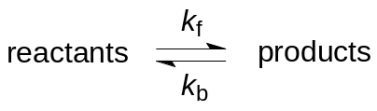 where k_{f} denotes the rate constant of the forward reaction and k_{b} denotes the rate constant of the backward reaction.
Potential energy
Reaction profile
reactants
products
E_{a}
ΔH
Which statements are correct?

1 k_{f} and k_{b} will increase in the presence of a catalyst.
2 Heating the equilibrium mixture will increase k_{f} but decrease k_{b}.
3 k_{f} will increase when the concentrations of reactants are increased.

34 Some standard redox potentials are given below.

Cu²⁺ + 2e⁻ ⇌ Cu +0.34 V

Ag⁺ + e⁻ ⇌ Ag +0.80 V

Co²⁺ + 2e ⇌ Co –0.28 V

Given the cell notation, Cu(s)⏐Cu²⁺(aq)⎥ ⎢Ag⁺(aq)⏐Ag(s)

Which statements are correct?

1 The mass of the silver electrode will increase.
2 When NaOH(aq) is added to the Cu²⁺(aq)⏐Cu(s) half–cell, the Eº_{cell} will become more positive.
3 When the Ag⁺(aq)⏐Ag(s) half–cell is replaced with the Co²⁺(aq)⏐Co(s) half–cell, the direction of electron flow in the external circuit will be reversed.

The responses A to D should be selected on the basis of

A | B | C | D
1, 2 and 3  are  correct | 1 and 2  only are  correct | 2 and 3  only are  correct | 1 only  is  correct

No other combination of statements is used as a correct response.

- Which of the following species show an increase in the radii?

- Ca²⁺ < K⁺ < Ar

- Cl⁻ < S²⁻ < P³⁻

- Na < Mg < Al

36 Use of the Data Booklet is relevant to this question.

Which of the following are correct statements for the sequence HCl – HBr – HI?

- The enthalpy change of formation becomes less exothermic.

- The polarity of the hydrogen halide molecule decreases.

- The thermal stability of the hydrogen halide decreases.

37 Compound Z gives white fumes with PCl₅, and releases ammonia gas upon addition of hot aqueous NaOH. Which compounds could be Z?

1 HO₂CCH₂CH₂CN
2 HOCH₂CH₂CONH₂
3 HOCH(CH₃)CH₂NH₂

38 In some reactions, the reactive carbon atom is not sp³ hybridised in the reactant molecule but becomes sp³ hybridised in the organic intermediate.

To which of the following reactions does this statement apply?
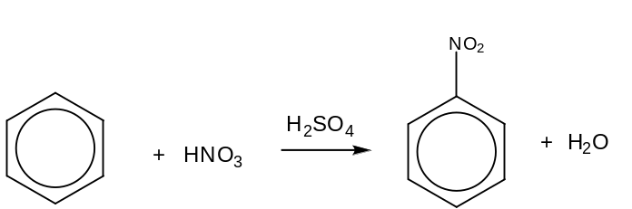

1

NaCN

2 CH₃CHO + HCN CH₃CH(OH)CN

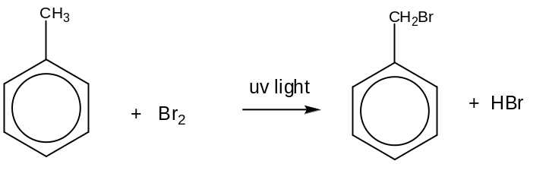

3

39 Which reactions would produce benzene–1,3–dicarboxylic acid?

1 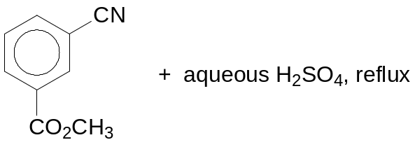

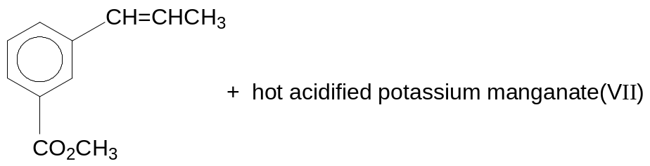

2

3 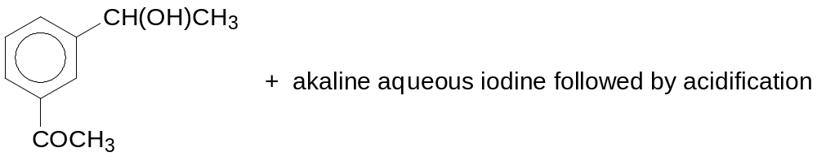

The responses A to D should be selected on the basis of

A | B | C | D
1, 2 and 3  are  correct | 1 and 2  only are  correct | 2 and 3  only are  correct | 1 only  is  correct

No other combination of statements is used as a correct response.

40 Psilocin is a psychedelic mushroom alkaloid which is the active compound that produces hallucinations from ingesting “magic mushrooms” and amplifies sensory experience. Compound K is a derivative of Psilocin.

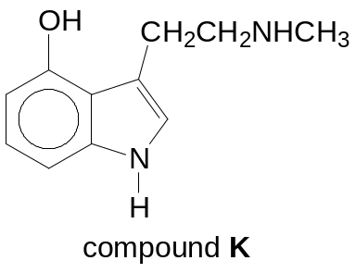

Which statements are correct for compound K?

1 It gives white fumes with CH₃COCl.
2 It reacts with both aqueous acids and alkalis.
3 The nitrogen–containing group in the ring has a lower pK_{b} than the nitrogen–containing group in the side chain.

End of paper

2010 Prelim H2 P1 Chemistry Answers

Paper 1: Multiple Choice

1 B | 2 A | 3 A | 4 C | 5 B
6 B | 7 C | 8 D | 9 C | 10 B
11 D | 12 D | 13 D | 14 B | 15 D
16 D | 17 A | 18 C | 19 B | 20 A
21 C | 22 C | 23 D | 24 C | 25 C
26 D | 27 C | 28 C | 29 D | 30 A
31 B | 32 A | 33 D | 34 A | 35 B
36 A | 37 B | 38 B | 39 A | 40 B

